Population Growth – Effects of the Environment

In biology, a population is a group of individuals of the same species that live in the same area at the same time. An example of a population is:
a flock of whooping cranes that live in a wetland in Texas during the winter and migrate to a wetland in Canada for the summer.

Recovery of Endangered Species – Why does it take so long?

An endangered species is a type of animal or plant that is at risk of becoming extinct because of low numbers and environmental threats. For example, the number of wild whooping cranes decreased from 10,000 or more before European settlement to about 20 in the 1940s. This drastic decrease was caused by hunting with guns and loss of wetlands as they were converted to farms and towns.  After the 1940s, conservation efforts included laws against killing whooping cranes and protection of the wetlands where whooping cranes were living. As a result, the surviving population of wild whooping | 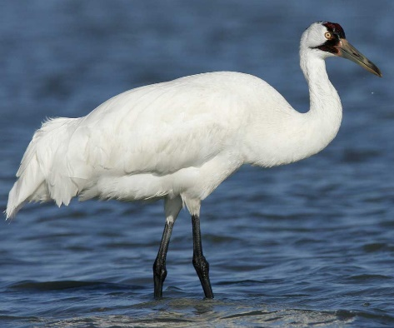  How tall do you think a whooping  crane is? To learn more and see whooping cranes in action, go to  this link or this link.
cranes increased from about 20 in the 1940s to more than 500 in 2025. Some data for this population are shown in the graph and table below.

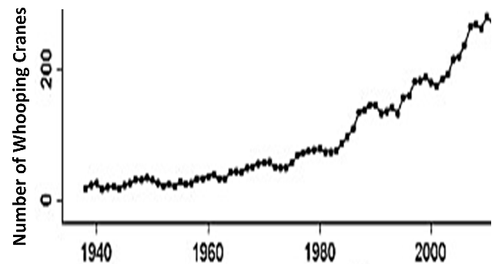
  Dates | Average number of whooping  cranes | Increase during the previous  20 years
  1950-1955 | 24.4
  1970-1975 | 53.0 | 28.6
  1990-1995 | 138.0 | 72.0
  2010-2015 | 290.6 | 152.6

1a. For this population of whooping cranes, did population size increase by the same amount during each 20-year period from 1950 to 2015? yes___ no ___

1b. On average, when was the increase in population size bigger?
in earlier decades ___ in more recent decades ___

2. What are possible reasons why the increases in population size have been bigger in more recent decades?

We will return to an analysis of the recovery of endangered species, but first you will learn more about population growth by analyzing simpler examples.

Bacterial Population Growth and Food Poisoning

A single bacterium is put in a container with plenty of food for bacteria. After 30 minutes the bacterium divides into two bacteria. Then, every 30 minutes, each bacterium in the container divides in two. As a result, population size doubles every 30 minutes.  3. Add to this figure to show how population size will double from 60 minutes to 90 minutes. | 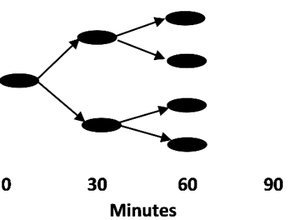

4. Complete this table to show how many bacteria there will be at each time if the number of bacteria doubles every 30 minutes.

Time (minutes) | 0 | 30 | 60 | 90 | 120 | 150 | 180 | 210 | 240 | 270 | 300
# Bacteria | 1 | 2

5. Graph the number of bacteria at each time. Connect the points to show the population growth curve.  6. Why did population size increase slowly at the beginning and more rapidly at later times? | 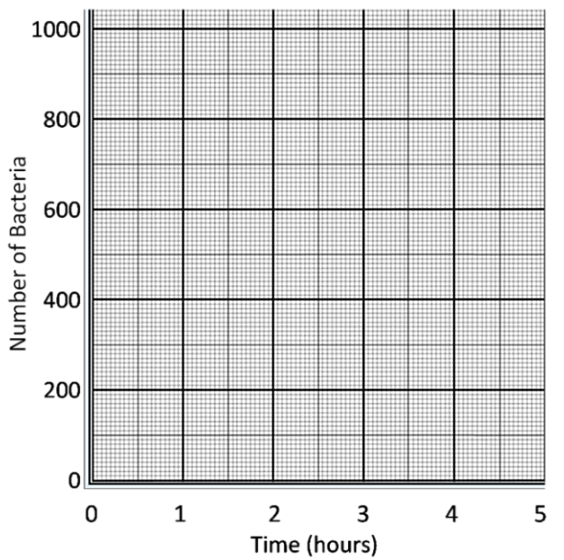

Notice that, when population size doubles in each time interval, the number of bacteria in the population increases faster and faster as the population gets larger. This is an example of exponential population growth. In exponential population growth, the rate of population growth increases as population size increases.

7. What evidence supports the hypothesis that the whooping crane population also showed roughly exponential population growth? (Hint: See the table on the previous page.)

The growth rate for a population depends on environmental conditions. For example, the growth rate for a population of Salmonella bacteria depends on temperature. A population of Salmonella bacteria can grow quickly if food is kept at room temperature, but the same population will hardly grow at all if the food is kept in the refrigerator.

If you eat food that has Salmonella bacteria in it, a population of Salmonella can grow in your intestines. A large enough population of Salmonella in your intestines will cause diarrhea, abdominal pain and other symptoms of food poisoning. However, if you eat food with just a few Salmonella bacteria, your immune system may kill the Salmonella before the population gets big enough to cause the symptoms of food poisoning.

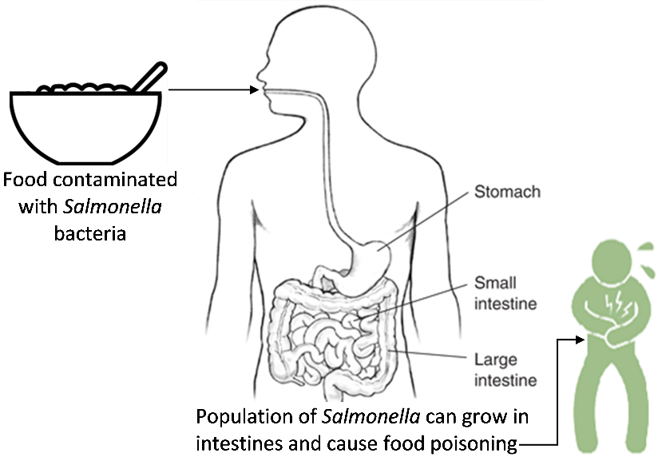

8. Explain why food that has been kept at room temperature for a few hours is more likely to cause food poisoning than food that has been kept in the refrigerator.

9. If a person eats food that contains Salmonella bacteria, the person does not get sick right away. Also, if a person has consumed fewer Salmonella, there is a longer delay between when the person eats contaminated food and when he or she experiences the first symptoms of food poisoning. What is happening during this delay?

10a. Think about a population of Salmonella in a bowl of food at room temperature that shows exponential population growth. Can exponential population growth continue forever? yes ___ no ___

10b. Why or why not?

Limits on Exponential Population Growth

This graph shows trends in population size for a population of bacteria that grew on a piece of tofu. During the first twenty hours, population size increased from a few hundred bacteria to about ten million bacteria. After that, population growth slowed and then stopped.  11. What is one possible reason why this population of bacteria stopped growing? | 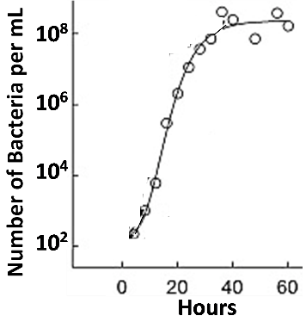

Paramecia are single-cell organisms that live in water and eat bacteria. This graph shows the results of an experiment with Paramecia.  Two populations of Paramecia grew in two tubes. These tubes had the same volume of | 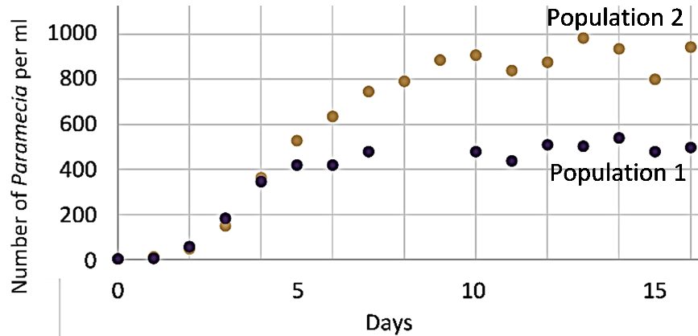
water. However, the tube where Population 2 grew had twice as much food for Paramecia as the tube where Population 1 grew.

12a. What was the main limiting factor that determined how many Paramecia could live in the tubes? the amount of food ___ the amount of space ___

12b. What evidence supports your answer?

13. As population size increases, competition for limited resources _________________.
(decreases/increases)
An increase in competition results in increased mortality and/or decreased
reproduction, so population growth slows and stops. As a result, population size reaches a _______________. This type of population growth is called logistic population growth.
(maximum/minimum)
In contrast, exponential population growth occurs when resources are ______________,
(abundant/scarce)
so there is little or no competition for resources.

14a. This figure shows the growth of two populations of the same kind of animal that live in two different environments. The amount of food and other resources in the environment is:  - much bigger for population A.  - much bigger for population B.  - about the same for both populations. | 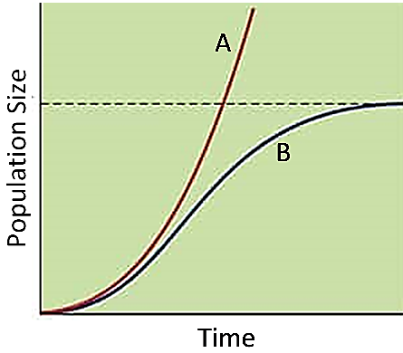
14b. Population ___ shows exponential population growth.
Population ___ shows logistic population growth.

Using the Exponential and Logistic Population Growth Models
to Understand Recovery of Endangered Species

A model is a simplified representation of reality that can help us to understand a real-world phenomenon. For example, the exponential and logistic population growth models help us to understand and predict changes in population size for endangered species.
In 1975, Jim predicted the future growth in the number of whooping cranes in Texas. He knew that this number had increased from about 24 in 1955 to about 53 in 1975.  Since population size had increased by about 30 in the past twenty years, Jim predicted that population size would increase by about 30 every twenty years in the future. | 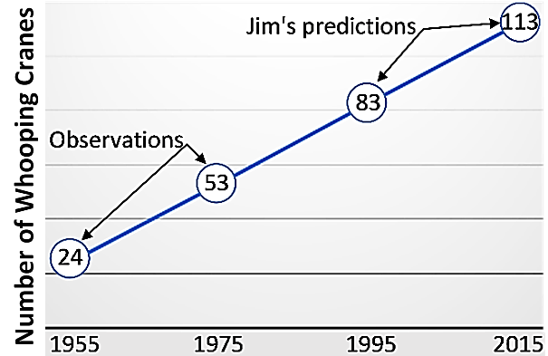

Thus, Jim predicted that, by 2015 (forty years after 1975), population size would reach approximately 53 + 30 + 30 = 113 whooping cranes. We now know that the actual population size in 2010-2015 was about 290, more than double Jim’s prediction.

15. What was wrong with Jim’s reasoning? Why was his prediction so much lower than actual population growth?

Conservation biologists have used two approaches to prevent the extinction of whooping cranes. First, they helped the one surviving population of wild whooping cranes to increase in size. Second, they tried to establish additional populations of whooping cranes in other locations. To achieve this second goal, the conservation biologists carefully trained the offspring of captive whooping cranes to survive in the wild. Then, they introduced these whooping cranes to new locations.

16a. Conservation biologists expected that, eventually, the total number of wild whooping cranes would be greater if there were additional populations in several different wetlands, instead of a single population in one wetland. Explain why.

16b. What is another reason why there is less risk of extinction if there are several populations of whooping cranes at different locations and not just one population in a single location?

The Endangered Species Act (ESA) was passed in 1973 to prevent the extinction of endangered species in the US. Critics argue that the ESA has been ineffective since, so far, only about 3% of all species covered by the ESA have recovered enough so they are no longer considered endangered.

In contrast, supporters of the ESA argue that only about 1% of species covered by the ESA have gone extinct. Also, population growth is expected to take a long time, especially when recovery efforts start from a very small population and the endangered species has a low birth rate. For many endangered species, population sizes have increased at expected rates.

Conservation biologists worry about the many species that are not yet endangered, but have decreasing total number of individuals. These decreases have been due to loss of the habitat that the species need and other hazards caused by people. If these trends continue, some of these species will probably become endangered.

17. Suppose you had to choose between conservation efforts that focus on endangered species vs. conservation efforts that focus on species that are not yet endangered, but have decreasing numbers. To help you choose your focus, complete this table.

Focus of Conservation Efforts | A Major Advantage of this Focus | A Major Disadvantage of this Focus
Endangered species
Species that have decreasing total population size, but are not yet endangered

By Dr. Ingrid Waldron, Biology Dept, University of Pennsylvania, © 2025. This Student Handout and Teacher Notes (with instructional suggestions and background biology) are available at https://serendipstudio.org/exchange/bioactivities/popgr. The recommended links under the picture of the whooping crane are the first 7 minutes of https://www.youtube.com/watch?v=ACUYXCLTvm8 and https://journeynorth.org/tm/crane/jr/JnKidsOverview.html.

